PROJECT CONCEPT DOCUMENT

AGRISAVE
A PYTHON MEMBER SAVINGS AND LOAN MANAGEMENT SYSTEM
FOR
Tukolere Wamu Agri Farmers SACCO - Mukono
Item | Details
Course Title & Code | BCS3202 – Systems Programming with Python
Lecturer in Charge | Mr. Nkoloogi Blasius
Demo Video (Public Link) | https://drive.google.com/file/d/1JXwgTIJu7BZIev3J1vXN7wjdilaIjDoG/view?usp=sharing
GitHub Repository | https://github.com/otim43/AGRISAVE-2026.git

Group Members
# | Name | Registration Number
1 | OTIM ISAAC | VU-BCS-2303-0302-DAY
2 | KALIBA MARVIN | VU-BCS-2311-0716-DAY
3 | KIIZA MICAH | VU-BSF-2403-0913-DAY
4 | LUKE GIDEON SHALOM | VU-BCS-2403-0895-DAY
5 | MUGWABI MUULA | VU-BCS-2403-0182-DAY
6 | KIIZA MICAH | VU-BSF-2403-0913-DAY
7 | OPIO PETER | VU-BCS-2403-1195-DAY

1. Project Title
AgriSave: A Python Member Savings and Loan Management System for Tukolere Wamu Agri Farmers SACCO - Mukono

2. Problem Statement
Mukono District represents one of central Uganda's most vital agricultural hubs, where thousands of smallholder farmers cultivate crops such as coffee, maize, bananas, cocoa, and horticultural produce. To pool financial resources and access affordable agricultural credit, farmers form community Savings and Credit Cooperative Societies (SACCOs). Tukolere Wamu Agri Farmers SACCO - Mukono was established to serve this exact operational mandate. However, relying on physical paper ledgers, counter books, and loose spreadsheets introduces significant administrative, financial, and operational risks:
- Inefficient Data Retrieval: Finding individual member records or debt statuses requires manual ledger searching, causing delays during monthly general meetings.
- Calculation Discrepancies: Manual aggregation of total capital, credit capacity, interest, and balances frequently leads to discrepancies between member passbooks and central ledgers.
- Subjective Credit Assessment: Discretionary loan approvals without automated business rule checks lead to inconsistent decision-making.
- Physical Record Vulnerability: Paper ledgers suffer from environmental damage and physical loss across outreach posts in Mukono.
- Lack of Real-Time Financial Visibility: SACCO executives cannot rapidly determine cumulative savings reserves, total active outstanding debt, or net SACCO liquidity without labor-intensive manual reconciliation.

AgriSave resolves these challenges by delivering a menu-driven Python console system featuring administrator login authentication, automated member management, savings deposits, credit processing with fixed interest calculations, loan repayments, bad debt write-offs, transaction audit trails, and multi-file text storage (tukolere_members.txt and tukolere_loan_transactions.txt).

3. Project Objectives

3.1 General Objective
To design, develop, and validate a Python-based menu-driven application that automates administrator authentication, member record registration, input validation, savings deposits, credit eligibility evaluation with fixed interest calculation, loan repayments, debt write-offs, transaction audit trail logging, and persistent text-file storage for Tukolere Wamu Agri Farmers SACCO - Mukono.

3.2 Specific Objectives
- Authenticate Administrator: To enforce security control using fixed admin credentials (admin / admin123) with a maximum of 3 login attempts prior to granting system access.
- Register New Members (Enrolment): To capture and validate member metadata, including unique Member ID, Full Name, Phone Number, Village, Main Crop Enterprise, initial Savings (UGX 0), and Outstanding Loan Balance (UGX 0).
- Manage Savings Deposits: To process savings deposits, automatically update member account cumulative totals, and issue official timestamped deposit receipts.
- Process Credit Origination & Loan Disbursement: To evaluate member loan eligibility (minimum UGX 100,000 savings and zero outstanding debt), enforce the maximum principal limit (2 × savings), apply a fixed 10% interest rate, and disburse credit with official timestamped receipts.
- Process Loan Repayments & Bad Debt Write-Offs: To allow members to settle active debt balances with repayment receipts and empower authorized operators to write off unrecoverable bad debt with official vouchers.
- Log Transaction Audit Trails: To record all credit operations (Disbursements, Repayments, Write-Offs) into a persistent, timestamped audit log file (tukolere_loan_transactions.txt).
- Search & Display Member Records: To retrieve individual member profiles instantly via case-insensitive partial string matching and render full directories in aligned tabular console views.
- Generate SACCO Portfolio & Financial Reports: To compute cumulative savings reserves, total loans disbursed, total repayments collected, bad debt written off, active outstanding debt, and overall net SACCO liquidity.
- Ensure Persistent Data Commit & Safe Exit: To maintain an active memory state flag (unsaved_changes) that prompts operators to commit pending updates to storage files before system shutdown or synchronization.

4. System Scope, Data Schema and Business Rules

4.1 System Scope
AgriSave is a single-user Command-Line Interface (CLI) application developed in Python 3 for execution at the SACCO branch office in Mukono. The application incorporates administrative login security, modular sub-menus, automated math logic, and persistent CSV text-file handling.

4.2 Data Schema & Field Constraints
Table 1: Member Master Record Schema (FIELDS)
Field Name | Data Type | Example | Validation & Constraint Rules
Member ID | String | TW001 | Must be unique; prefix 'TW' followed by exactly 3 digits (^TW\d{3}$).
Full Name | String | Kizito Joseph | Must contain at least 3 alphabetic characters; letters, spaces, apostrophes, dots, and hyphens allowed.
Phone Number | String | 0772345678 | Exactly 10 digits; starts with valid telecom prefixes (077, 078, 070, 075, 076, 074, 079, 073).
Village / Cell | String | Kyetume | Non-empty string; must not contain commas (CSV format protection).
Main Enterprise | String | Coffee | Standardized agricultural commodities (Coffee, Maize, Cocoa, Dairy, Poultry, Bananas).
Savings (UGX) | Float / Int | 250000 | Numeric value; non-negative (>= 0). Initialized at UGX 0 during enrolment.
Loan Balance (UGX) | Float / Int | 110000 | Numeric value; non-negative (>= 0). Reflects total repayable principal + interest.

Table 2: Loan Transaction Audit Log Schema
Field Name | Data Type | Example | Description & Rules
Timestamp | String | 2026-10-07 14:30:00 | ISO format timestamp generated at transaction time (%Y-%m-%d %H:%M:%S).
Member ID | String | TW001 | Unique ID referencing the member account.
Name | String | Kizito Joseph | Full name of the member at transaction time.
Transaction Type | String | DISBURSEMENT | Categorized as DISBURSEMENT, REPAYMENT, or WRITE_OFF.
Amount (UGX) | Float / Int | 100000 | Monitored monetary amount involved in the transaction.
Balance After | Float / Int | 110000 | Outstanding member loan balance remaining immediately after the transaction.

4.3 Business Rules & Mathematical Equations
# | Rule | Equation / Logic
1 | Savings Deposit Processing | Updated Savings Balance = Current Savings + Deposit Amount
2 | Maximum Borrowing Principal Limit | Maximum Principal Limit = LOAN_MULTIPLIER × Member Savings = 2 × Savings
3 | Fixed Interest Policy & Total Repayable Sum | Fixed Interest Rate = 10% (0.10) applied on disbursed principal.  Interest Charge = Disbursed Principal × 0.10  Total Repayable Debt = Disbursed Principal + Interest Charge
4 | Loan Qualification Eligibility Rule | A member qualifies for credit ONLY IF:  (a) Member Savings Balance >= UGX 100,000 (MIN_SAVINGS_FOR_LOAN).  (b) Member Outstanding Loan Balance == UGX 0.  If non-compliant, status is set to REJECTED and specific reasons are output.
5 | Loan Repayment Processing | Updated Outstanding Debt = Current Debt Balance - Repayment Amount
6 | Bad Debt Write-Off Processing | Adjusted Outstanding Debt = Current Debt Balance - Write-Off Amount
7 | Institutional Liquidity Metrics | Net SACCO Liquidity Balance = Cumulative Member Savings Reserve - Total Active Outstanding Debt

4.4 File Storage Structure
Data persistence is managed using two plain-text CSV files:
1. tukolere_members.txt (Master Account File):
TW001,Kizito Joseph,0772345678,Kyetume,Coffee,250000,0
TW002,Namasole Sarah,0701987654,Nakifuma,Maize,500000,220000

2. tukolere_loan_transactions.txt (Transaction Audit Log File):
2026-10-07 10:15:22,TW002,Namasole Sarah,DISBURSEMENT,220000,220000
2026-10-07 11:00:45,TW002,Namasole Sarah,REPAYMENT,50000,170000

5. Conceptual System Diagram & Architecture (IPOS Model)
The diagram below shows the Input–Process–Output–Storage (IPOS) architecture of AgriSave. Inputs from the SACCO officer flow into the processing engine, which produces outputs for the officer and exchanges data with the storage layer through save and load operations.
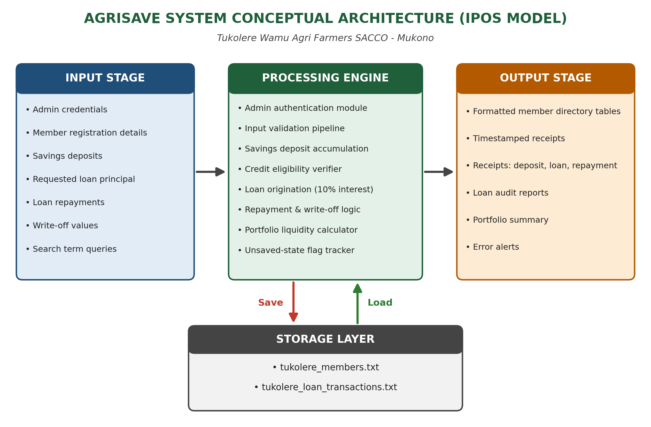
Figure 1: AgriSave System Conceptual Architecture (IPOS Model)
- Input Stage: Captures administrator login details, new member demographic profiles, savings deposit values, loan requested amounts, repayment values, write-off values, and search queries.
- Processing Engine: Validates input regex patterns, enforces credit rules, computes 10% interest fees, handles debt write-offs, tracks transaction timestamps, calculates total portfolio metrics, and manages memory state flags.
- Output Stage: Renders structured terminal tables, timestamped official transaction receipts/vouchers, portfolio financial overviews, and real-time operational feedback.
- Storage Layer: Provides bidirectional serial loading and persistent writing for tukolere_members.txt and tukolere_loan_transactions.txt.

6. UML Use Case Diagram and Functional Requirements
The use case diagram shows the single actor, the SACCO Officer (System Admin), and the 14 primary use cases offered by the AgriSave system boundary. UC15 (Validate Input) and UC16 (Log Transaction Audit Entry) are included sub-routines.
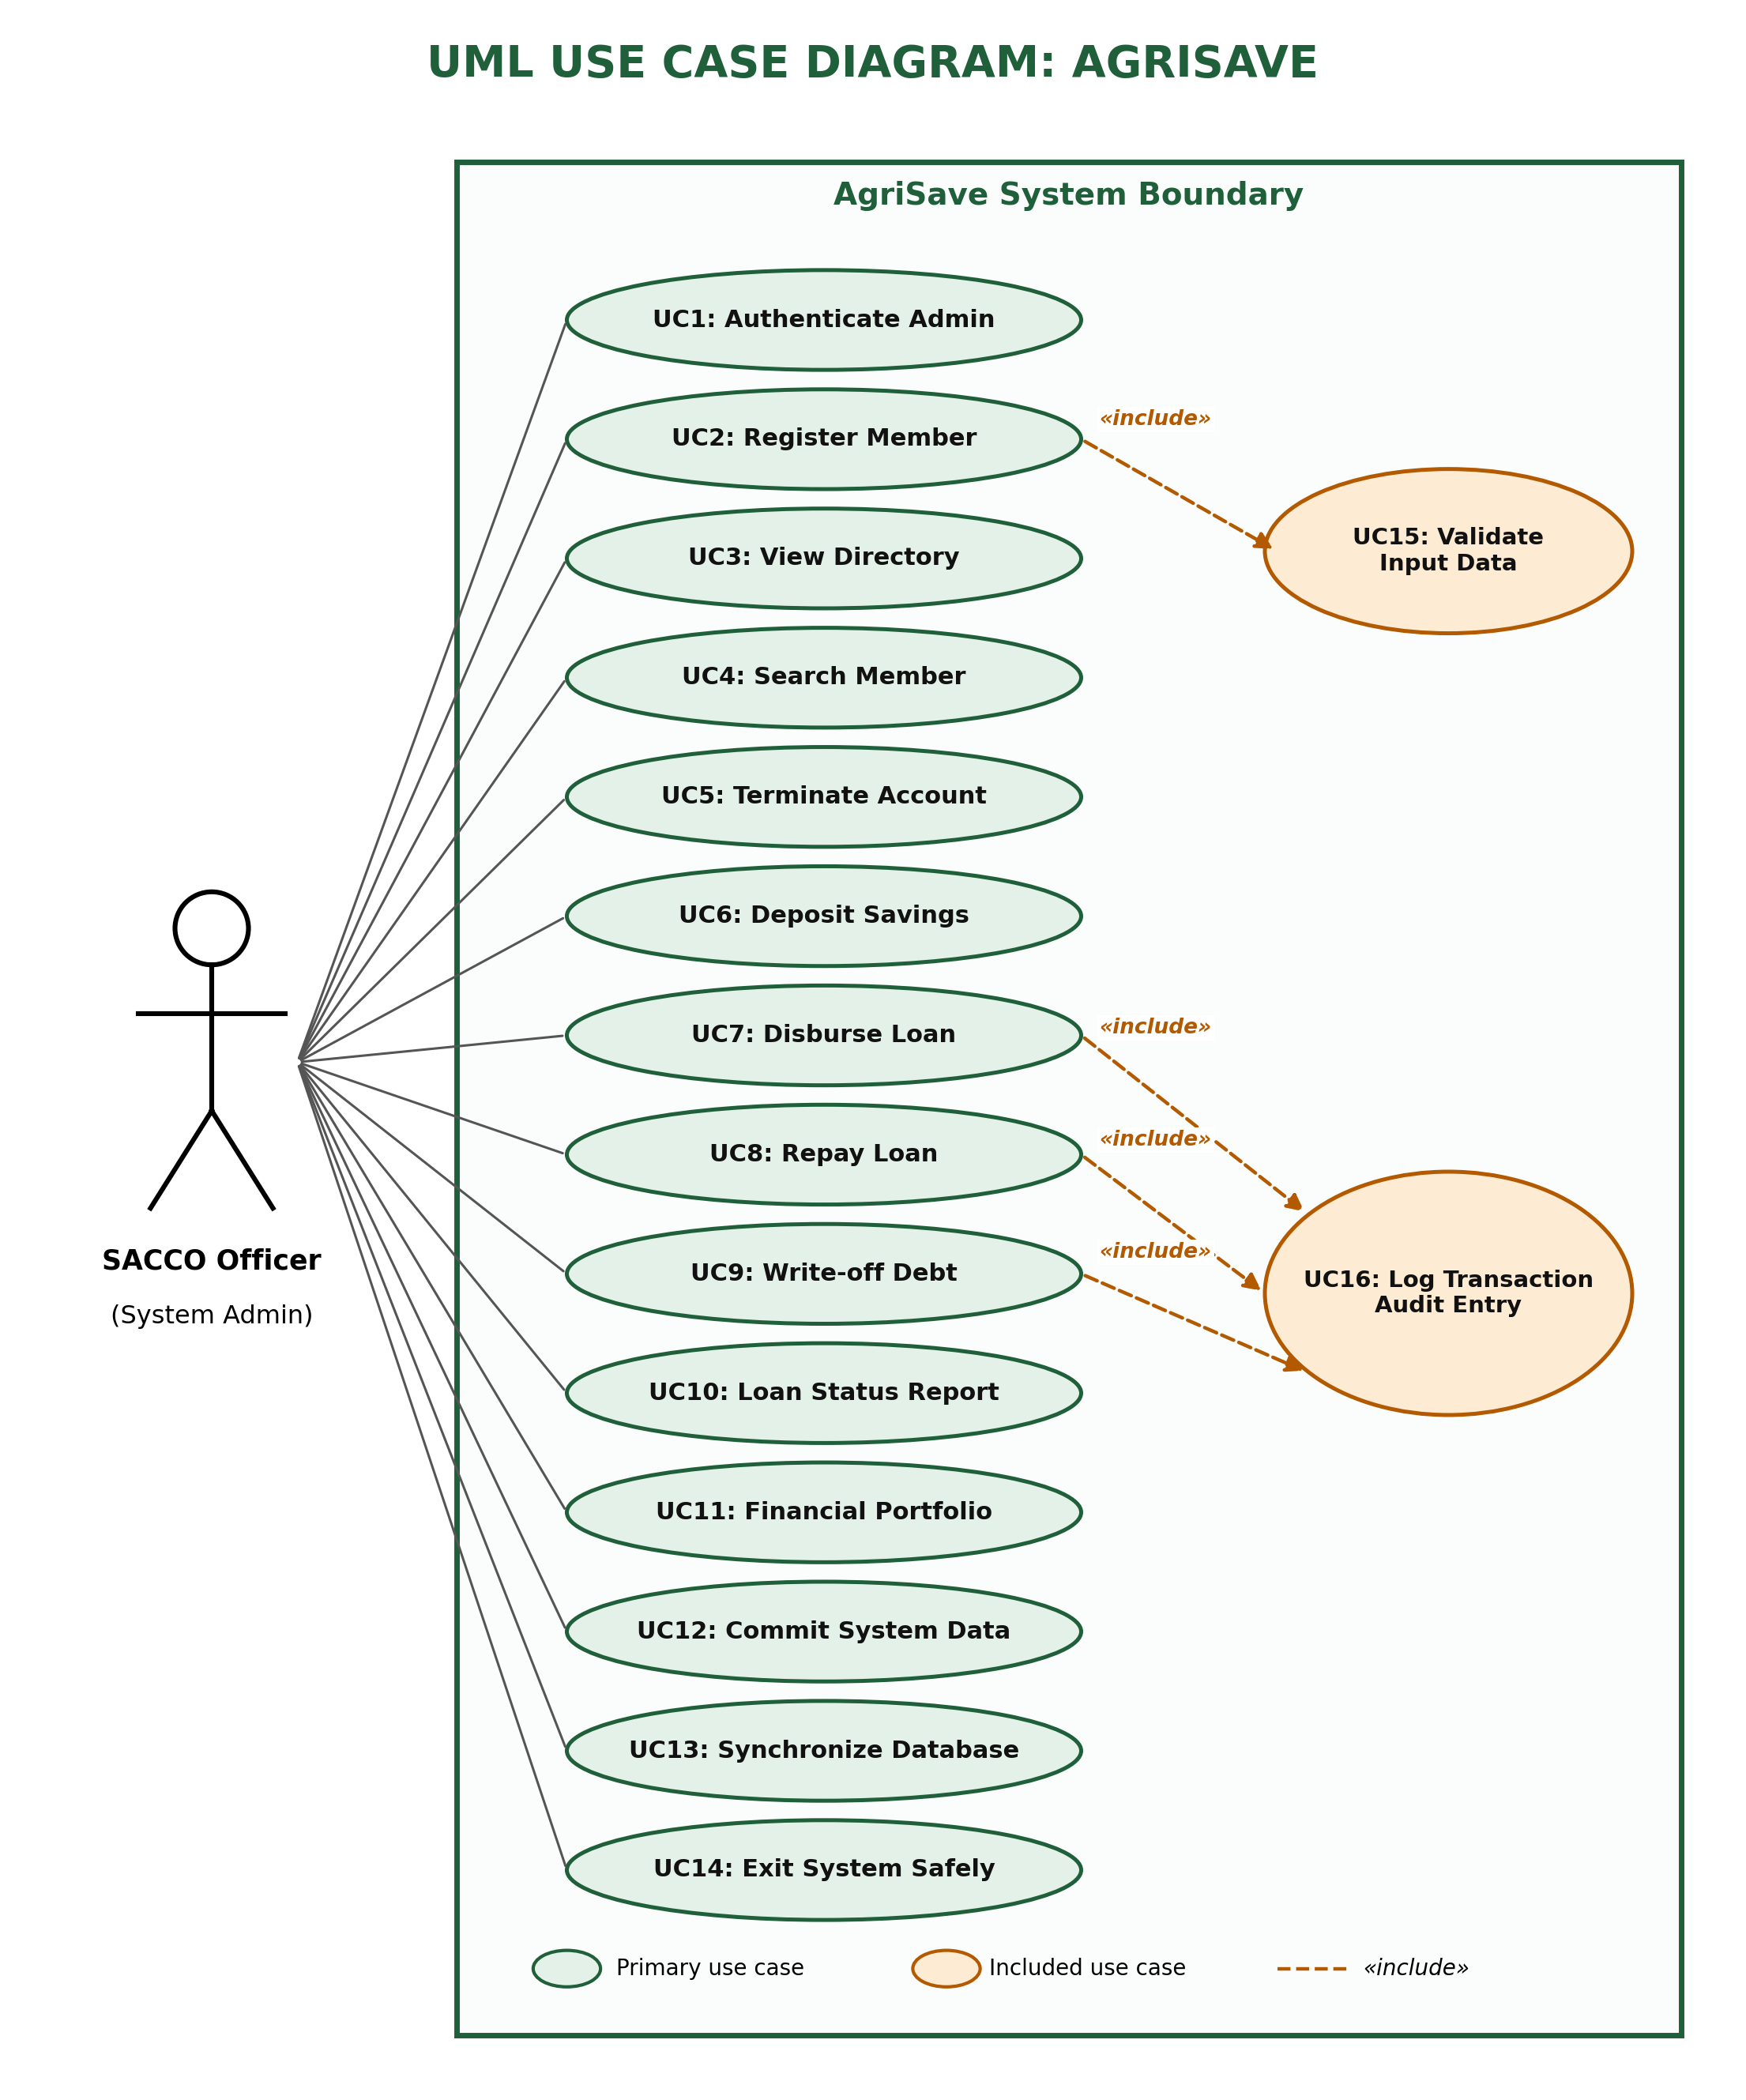
Figure 2: UML Use Case Diagram for AgriSave

6.1 Functional Requirements Summary
Use Case ID | Use Case Name | Functional Logic & Implementation Summary
UC1 | Authenticate Administrator | Verifies credentials against fixed admin settings (admin/admin123) with a maximum 3-attempt limit.
UC2 | Register Member Record | Captures member details, validates input rules (UC15), ensures ID uniqueness, and initializes account with UGX 0 savings and loan debt.
UC3 | View Member Directory | Displays active member records sorted by Member ID in an aligned tabular layout.
UC4 | Search Member Account | Performs partial case-insensitive string matching on Member ID or Full Name and renders matching records.
UC5 | Terminate Account | Prompts operator for confirmation before permanently purging a member record from system memory.
UC6 | Deposit Savings | Prompts for deposit amount, updates member cumulative savings, marks unsaved state, and generates an official timestamped receipt.
UC7 | Disburse Loan | Evaluates credit qualification (savings >= 100k, zero debt), checks 2x borrowing principal limit, applies 10% fixed interest rate, disburses credit, logs transaction (UC16), and issues receipt.
UC8 | Repay Loan | Accepts repayment towards active loan debt, updates remaining balance, logs transaction (UC16), and prints repayment receipt.
UC9 | Write-off Bad Debt | Authorizes unrecoverable loan write-offs, adjusts remaining debt balance, logs transaction (UC16), and prints a write-off voucher.
UC10 | Loan Status Report & Audit Trail | Displays member debt statuses alongside a complete, timestamped audit log table retrieved from transaction memory.
UC11 | Financial Portfolio Overview | Generates institutional summary (total savings reserve, disbursed loans, repayments, bad debt written off, active debt, net liquidity balance) and member portfolio breakdown.
UC12 | Commit System Data | Writes memory datasets to tukolere_members.txt and tukolere_loan_transactions.txt, resetting the unsaved state flag.
UC13 | Synchronize Database | Reloads text storage files into memory, warning operator if uncommitted memory changes exist.
UC14 | Exit System Safely | Checks unsaved_changes flag and prompts user to commit pending changes before shutting down session.
UC15 | Validate Input Data (Included) | Sub-routine validating regular expressions for phone numbers, member IDs, names, non-empty fields, and non-negative amounts.
UC16 | Log Transaction Audit Entry (Included) | Sub-routine writing timestamped records (DISBURSEMENT, REPAYMENT, WRITE_OFF) to the transaction audit list.

7. Main Menu Structure in Implementation
=========================== AGRISAVE - 2026 © ===========================
Tukolere Wamu Agri Farmers SACCO - Mukono
================================================================
1. Member Account Directory
1. Register New Member
2. View Full Member Directory
3. Search Member Account
4. Terminate Member Account
5. Return to Main Dashboard
2. Savings & Deposit Operations
3. Credit Origination & Loan Processing
1. Issue / Disburse Loan (At 10% Interest Rate)
2. Settle / Repay Loan
3. Write-Off Bad Debt
4. Return to Main Dashboard
4. Loan Status Report & Audit Trail
5. Financial Reports & Overview
6. Commit System Changes (Save Data)
7. Synchronize Database (Reload Data)
8. Exit System
----------------------------------------------------------------

8. Conclusion
AgriSave provides a digital management solution specifically customized for Tukolere Wamu Agri Farmers SACCO - Mukono. By replacing vulnerable paper ledgers with a Python console application, the system automates input validation, enforces objective credit policies, calculates a fixed 10% interest rate, handles debt write-offs, produces timestamped audit receipts, and maintains persistent multi-file text storage.

